*Florida International University*

*School of Computing and Information Sciences*

CIS 4911 - Senior Capstone Project

Software Engineering Focus

Feature Document

User Story # 546

**Team Member:**

Garrett Lemieux

**Product Owner(s)**:

Francisco Ortega

**Mentor(s)**:

Francisco Ortega

**Instructor**: Masoud Sadjadi

**User Story – Implement functioning leap motion gestures**

* As a User I want preset Leap Motion gestures so I can perform additional functionality within the interactive paint program.
* **Acceptance Criteria**:

1. Create at least two gestures to be used by TouchPointsApp.
2. User must be provided basic feedback that gesture was detected.

**Use Case: User Performs Leap Motion Gesture**

Gesture Implementation and Recognition

* Details:
* Actor:
  + User
* Pre-conditions:
  + Leap Motion device is connected to TouchPointsApp.
  + TouchPointsApp is running.
* Description:
  + Use case begins when User want to perform a preset gesture for paint program.
  + User can perform circle gesture to interact with proximity menu.
  + User can perform swipe gesture to change current color.
  + User can perform keyboard tap gesture to save canvas.
  + Use case ends when User no longer wants to alter program setting or save current canvas using leap motion gestures.
* Post-conditions:
  + User should be provided appropriate feedback for each gesture recognized.
    - * Circle Gesture – Proximity menu should appear and four distinct quadrants observed.
      * Swipe Gesture – Box should appear with new color and fade out.
      * Keyboard Gesture – Save icon should appear and fade out.
* Decision Support:
  + Frequency: Medium, Gestures will be needed to select modes and change the state of paint program when leap motion is primary device.
  + Criticality: High, User must be able to have full functionality when leap motion device is the only device connected.
  + Risk: High, Developer had to learn leap motion SDK and leap motion technology.
* Constraints:
  + Leap Motion SDK must be used.
  + Can only use data provided by Leap Motion Service.
* Usability:
  + User must read and understand user guide.
  + User must spend some time learning the gestures and follow directions. May have to alter the way gestures are made depending on his or her anatomical makeup.
* Reliability
  + Reliable
* Performance
  + Performance High
  + Failure Low
* Supportability
  + Leap Motion Device
* Modification History:
  + Owner: Garrett Lemieux
  + Initiation Date 02/01/2016
  + Date last Modified: 04/28/2016

**Use Case Diagram**

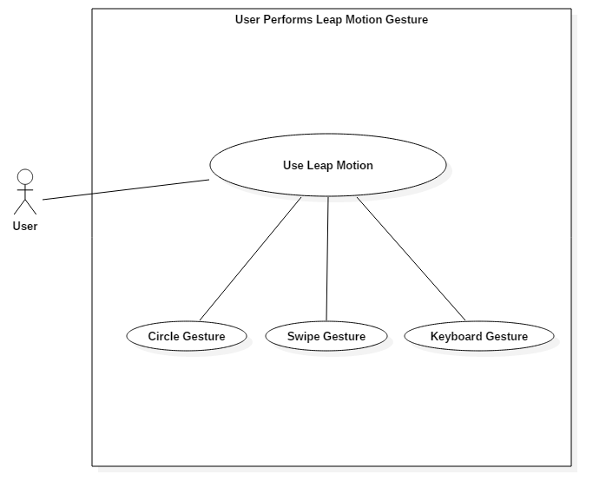

**Sequence Diagram**

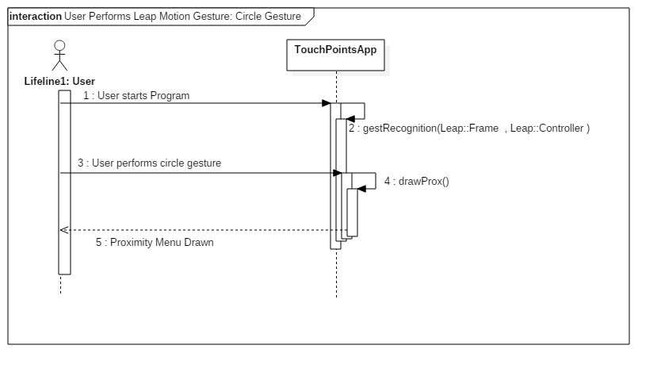

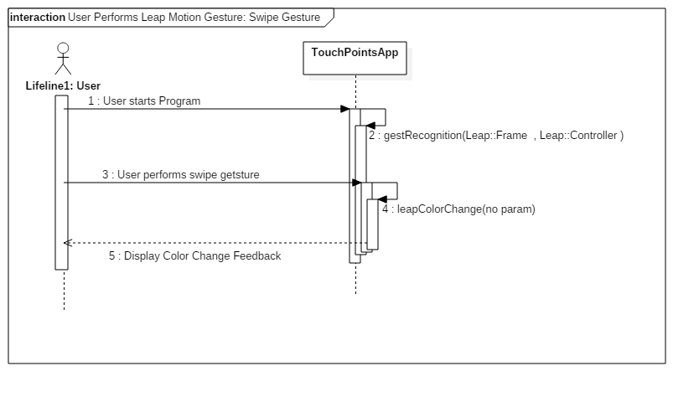

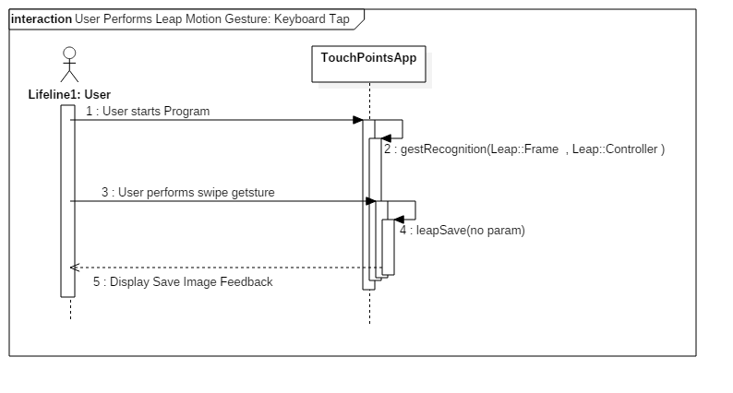

**Class Diagram**

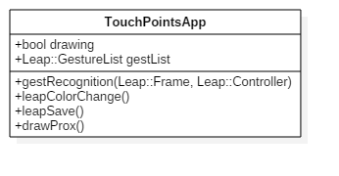

**Unit Test**

* Sunny Day Test:
  + Test Case  - Test if Circle Gesture is Detected
    - Test Purpose: To determine if user perform circle gesture and it is detected by paint program.
    - Test Procedure: User starts program. He or she then performs a circle gesture while hand is over leap motion.
    - Expected Results: Use should see a proximity menu appear.
  + Test Case  - Test if Swipe Gesture is Detected
    - Test Purpose: To determine if user perform swipe gesture and it is detected by paint program.
    - Test Procedure: User starts program. He or she then performs a swipe gesture while hand is over leap motion.
    - Expected Results: Use should see feedback in the form of a box that has new color setting and slowly fades out.
  + Test Case  - Test if Keyboard Gesture is Detected
    - Test Purpose: To determine if user perform keyboard gesture and it is detected by paint program.
    - Test Procedure: User starts program. He or she then performs a keyboard gesture while hand is over leap motion.
    - Expected Results: Use should see feedback in the form of a save icon appearing and fading out.
* Rainy Day Test:
  + Test Case  - User Trys to Perform Two Gestures Back to Back
    - Test Purpose: Test if a person performs two gestures within one sec the program responds correctly.
    - Test Procedure: User starts program and performs a swipe gesture. Immediately following the completion of the swipe gesture he or she performs a circle gesture.
    - Expected Results: User should see feedback in the form of a color change since a swipe gesture was made. He or she should not see the proximity menu appear since the program does not allow another gesture to be read until feedback has faded out. If proximity appears test failed.

**Integration Testing**

* The ability to use the circle, swipe, and keyboard tap gestures with leap motion while all other devices are connected was successful.
* The circle gesture was used to enable proximity menu and proximity menu functioned correctly. Any draw setting changed using proximity menu functioned correctly with multitouch.
* The swipe gesture was used to change the draw setting current color on recognition of the swipe gesture setting was changed and multitouch was able to draw with new color.
* The keyboard tap gesture was used to save canvas. Canvas was succesfullly saved when gesture used and the device that created the canvas did not affect the result.
* TouchPointsApp previous functionality was retained after integrating leap motion gestures.

**User Guide**

* Devices Used: Acer Multitouch and Leap Motion

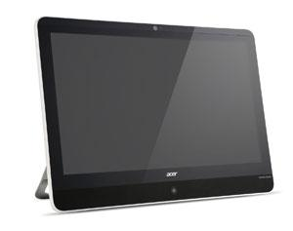

* Acer - Multitouch

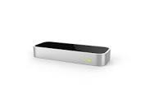

* Leap Motion
* User must have the Leap Motion gestures enabled.
* The user must have his or her hand over the leap motion device to perform a hand gesture.
* In order to perform a circle gesture user must have one or two fingers extended. In a smooth continuous movement complete at least one rotation in either the clockwise or counterclock wsie direction.
  + Either hand can be used
  + An example can be seen below

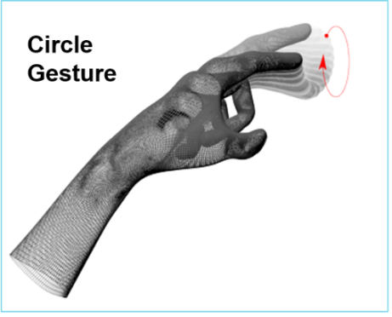

* In order to perform a swipe gesture user must have his or her hand over the leap motion device. He or she must accelerate their hand in a horizontal direction from one side of the leap motion to other or in a vertical direction.
  + Right to left or left to right
  + Top to Bottom or Bottom to top
  + Either hand can be used.
  + An Example can be seen below

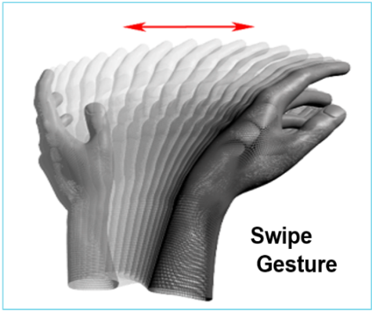

* Keyboard Tap Gesture user must have his or her hand over the leap motion device. He or she must make a quick downward tapping motion with their finger extended.
* User should image pressing a piano key.
* Gesture is a distinct motion and only one keyboard tap recognized per user gesture.
  + Either hand can be used.
  + An Example can be seen below.

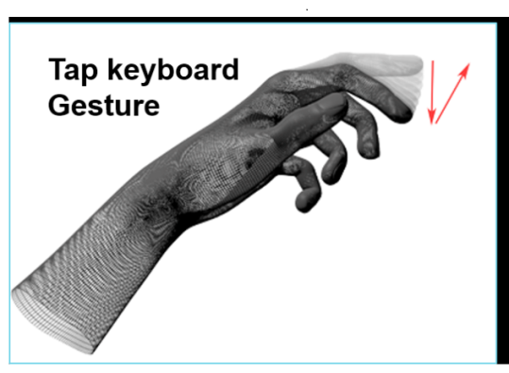

**Glossary**

* Hand Gesture Recognition- hand gesture recognition technology in leap motion uses infrared camera reads the movements of the human hand and communicates the data to a computer the implemented as input to control devices or applications.